California State University Fullerton

CPSC 462



Object Oriented Software Design

Implementation Model

for the

1. Update placeholder with your project’s title being careful not to delete the (potentially hidden) bookmark. If you did it right, the document’s footer will be updated too
2. Delete this bubble

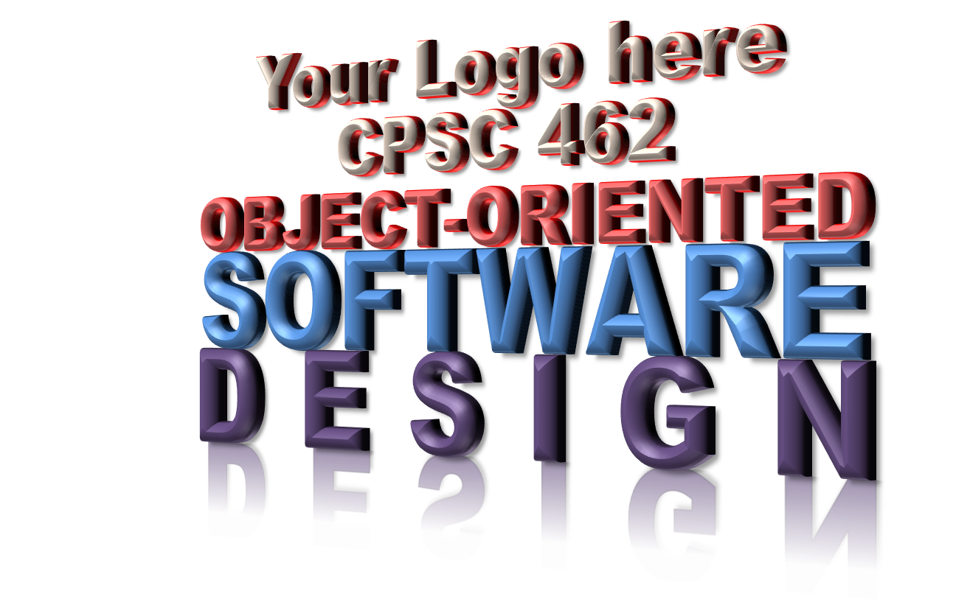

<Your Project Title here>

System

|  |  |  |
| --- | --- | --- |
| **<Student Name 1 here>** | **<Student Name 2 here>** | **<Student Name 3 here>** |
| <Title / Roll within project> | <Title / Roll within project > | <Title / Roll within project > |
| <[Email1@csu.fullerton.edu](mailto:Email1@csu.fullerton.edu)> | <[Email2@csu.fullerton.edu](mailto:Email2@csu.fullerton.edu)> | <[Email3@csu.fullerton.edu](mailto:Email3@csu.fullerton.edu)> |

Revision History:

| Version | Date | Summary of Changes | Author |
| --- | --- | --- | --- |
| 1.0 | <date of release> | * Initial Release | <Name 1>  <Name 2>  … |
|  |  |  |  |
|  |  |  |  |
|  |  |  |  |

Table of Contents

1 Software Design to Source Code Cross-Reference 1

1.1 Static View Design to Source Code Implementation Cross-Reference 1

1.2 GRASP Pattern Design to Source Code Implementation Cross-Reference 1

1.3 Logical View Interfaces to Source Code Implementation Cross-Reference 1

2 System Build Instructions 2

2.1 Windows Build Instructions 2

2.2 Linux Build Instructions 2

2.3 Macintosh Build Instructions 2

3 Source Code 2

NOTE TO STUDENTS:

1. See Larman Chapter 20 Mapping Designs to Code, §39.1 The SAD and its Architectural Views
2. Delete this NOTE before you deliver

# Software Design to Source Code Cross-Reference

## Static View Design to Source Code Implementation Cross-Reference

<What source and header files implement the class. Sort this list by class name. It is also suggested you annotate the Class Diagram with the header file information>

| Class Name | Source code file name | Line number(s) |
| --- | --- | --- |
|  |  |  |
|  |  |  |

## GRASP Pattern Design to Source Code Implementation Cross-Reference

<Looking for you to show me (point me to) an example in the code where each of the 5 GRASP patterns is implemented.>

| Pattern | Source code file name(s) | Line number(s) |
| --- | --- | --- |
| Low Coupling / High Cohesion Pattern |  |  |
|  |  |
|  |  |
| Creator Pattern |  |  |
|  |  |
|  |  |
| Information Expert Pattern |  |  |
|  |  |
|  |  |
| Controller Pattern |  |  |
|  |  |
|  |  |
| Polymorphism Pattern |  |  |
|  |  |
|  |  |
| Protected Variations Pattern |  |  |
|  |  |
|  |  |

## Logical View Interfaces to Source Code Implementation Cross-Reference

| Interface Class Name | Source code file name | Line number(s) |
| --- | --- | --- |
|  |  |  |
|  |  |  |

# System Build Instructions

## Windows Build Instructions

<Need a command line procedure. Don’t expect your customer to open, say Visual Studio for example and navigate buttons. Need something like, Open a Power Shell console window, set the default working directory to XYZ, and execute this command: ABC. Keep it simple.>

## Linux Build Instructions

<Need a command line procedure. Don’t expect your customer to open, say Visual Studio Code for example and navigate buttons. Need something like, Open a Bash console window, set the default working directory to XYZ, and execute this command: ../Build.sh. Keep it simple.>

## Macintosh Build Instructions

<Need a command line procedure. Don’t expect your customer to open, say XCode for example and navigate buttons. Need something like, Open a Bash console window, set the default working directory to XYZ, and execute this command: make -f ../Makefile. Keep it simple.>

# Source Code

<Provide the name of a zip file containing the source code. Of course, in real life you would provide the location as well, but I know your zip file will be included in your Canvas delivery. Make sure the only thing in the zip file is the source code, maybe some a data file and a Readme file. No executable or object files. No solution or project files.>

<OPTIONAL: provide the name of a zip file containing your development environment. Just be sure to separate your source code delivery from the environment and tools that builds that source code.>